**Design Document**

**Software Engineering 3**

**DT228/3**

**D17124591**

**Jianyu He**

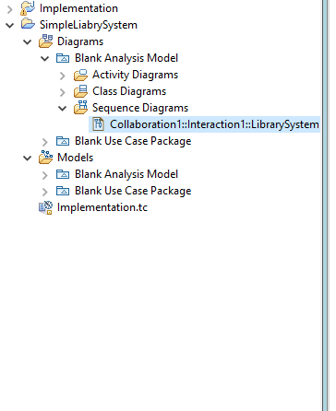

I am doing simple library system, in this system have use case package, analysis model and sequence diagram.

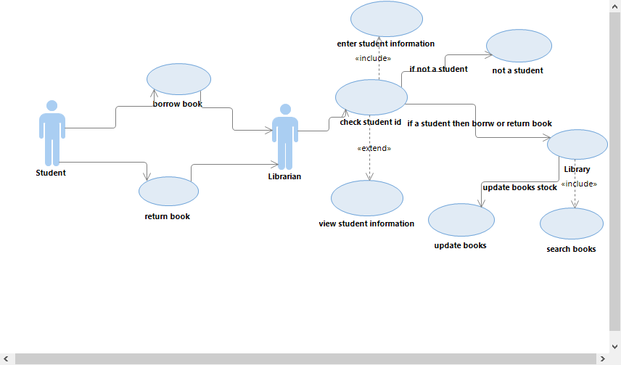

This is my use case diagram, the use case narrative is :

There is a student actor want borrow or return book then go to library to ask librarian.

Librarian have to check student id to check this person is student.

When librarian check student id he has to enter student information.

Librarian can view student information, but it is not necessary.

If student id is wrong then will tell this person you are not a student, don’t allow to borrow or return books.

If student id is correct then librarian go to library to search book.

When student already borrow or return book, then librarian have to update book stock of library.

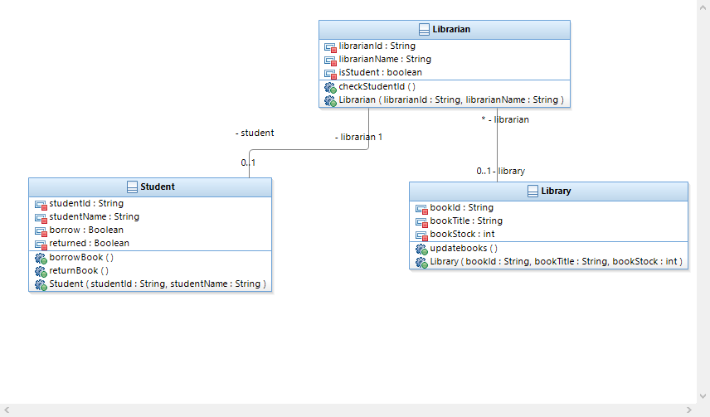

This is my class diagram, there have 3 class, those class have relationship between each class. Student class have 4 attributes and 3 operations. Librarian class have 3 attributes and 2 operations. Library have 3 attribute and 2 operations. Relationship between student and librarian is 0..1 to 1, relationship between librarian and library is many to 0 or 1.

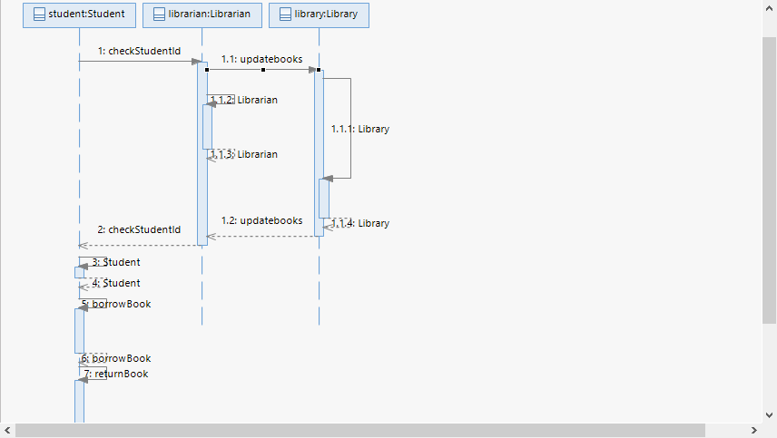

This is my sequence diagram, there are 3 class and some operation between each class.

Student need check student if by librarian, if student id is correct then allow student to borrow or return book. If student borrow or return successful then librarian have to update book stock of library.

Presentation video link:

<https://youtu.be/u9VtOnKVKE4> or

<https://www.youtube.com/watch?v=u9VtOnKVKE4&feature=youtu.be>